**Marketing Insight Report by Maryam Ibrahim Hamza**

**Introduction**

This report provides an exploratory analysis of a dataset sourced from a U.S.-based company that sells products across three main categories: Technology, Furniture, and Office Supplies. This analysis aims to identify key sales trends, top-performing product categories, and geographical insights to support strategic marketing decisions.

**Data Overview**

The dataset comprises sales data without missing values, containing various data types such as floating-point numbers, integers, and categorical variables. The data includes product categories, sub-categories, sales figures, and profitability metrics.

**Key Observations**

**1. Sales by Category**

The total sales generated across the three primary categories are as follows:

* **Technology**: $836,154.03
* **Furniture**: $741,999.79
* **Office Supplies**: $719,047.03

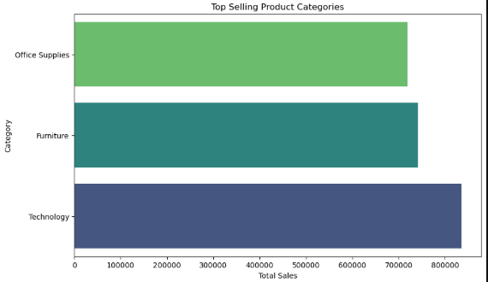

Among these, the **Technology category** is the highest-grossing, followed closely by Furniture and Office Supplies.

**2. Profitability by Category**

While sales volume is a critical metric, profitability is equally important. The respective profits generated by each category are:

* **Furniture**: $18,451.27
* **Office Supplies**: $122,490.80
* **Technology**: $145,454.95

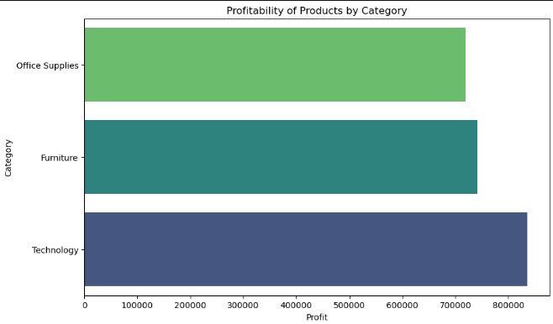

Although the **Furniture category generates significant sales, its profit margins are notably lower** compared to the other categories.

**3. Top-Selling Sub-Categories**

An analysis of sub-categories reveals the top-performing products by total sales revenue:

* **Phones**: $330,007.05
* **Chairs**: $328,449.10
* **Storage**: $223,843.61
* **Tables**: $206,965.53
* **Binders**: $203,412.73

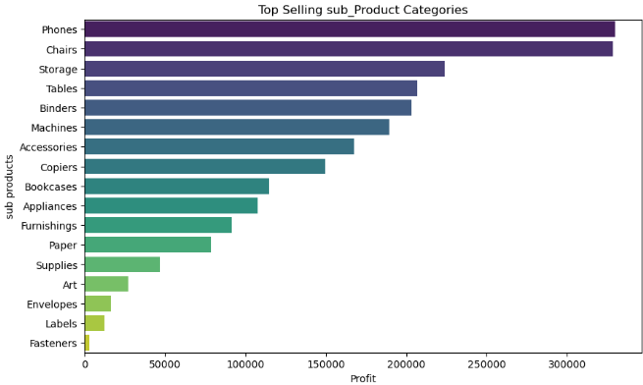

Phones and Chairs lead in sales volume, highlighting strong consumer demand in these segments.

**4. Regional Sales Performance**

The dataset includes sales data from various cities across the U.S. The top-performing cities in terms of sales include:

* **New York City, Los Angeles, Seattle, San Francisco, Philadelphia, Houston, Chicago, San Diego, Jacksonville, and Springfield**

Additionally, sales distribution by region indicates:

* **West Region**: Highest sales volume
* **East Region**: Second highest
* **Central Region**: Moderate sales
* **South Region**: Lowest sales volume

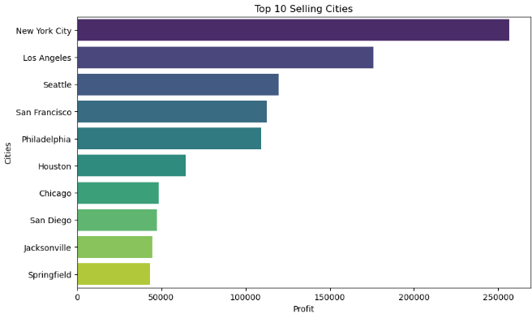

This insight suggests potential opportunities for increased marketing efforts in underperforming regions, particularly in the **South U.S.**

**Conclusion & Recommendations**

Based on the initial analysis, the following strategic insights can be drawn:

1. **Technology products** are the most profitable and should be prioritized in marketing campaigns.
2. **Furniture sales are high, but profit margins are low**, indicating potential pricing strategy adjustments or cost optimizations.
3. **Phones and Chairs are top-selling sub-categories**, suggesting strong demand that should be leveraged in promotional efforts.
4. **The West region outperforms others**, while the South region presents an opportunity for targeted sales and marketing strategies.

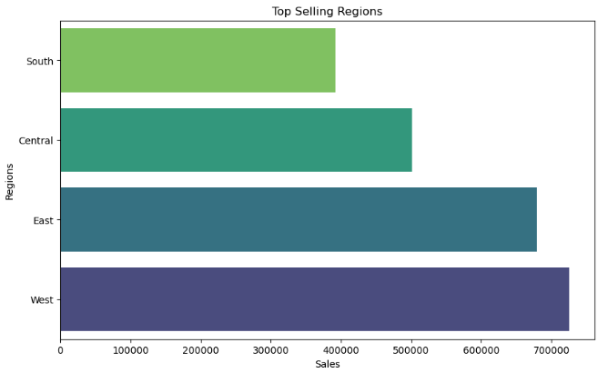

**Conclusion**

The analysis of the sales dataset highlights key trends and opportunities for strategic decision-making. Technology emerges as the highest-grossing and most profitable category, making it a strong candidate for prioritized marketing efforts. Despite high sales, the Furniture category has relatively low profitability, suggesting a need for pricing adjustments or cost optimizations. Phones and Chairs stand out as top-selling sub-categories, indicating strong consumer demand that can be leveraged in promotions.

Geographically, the West region outperforms others in sales, while the South region presents a potential growth opportunity. Targeted marketing and sales initiatives in underperforming regions could help balance revenue distribution.

For further analysis, deeper insights into customer demographics, seasonal sales trends, and pricing strategies could provide more refined business strategies. Additionally, exploring customer preferences and competitive market dynamics may further optimize sales and profitability.

For more details on the HNG Internship program, visit <https://hng.tech/internship>, to explore opportunities or <https://hng.tech/hire/data-analysts> to hire a data analyst.